SHULL SCIENCE · JAMES A. GARFIELD LOCAL SCHOOLS
LIGHT FROM ELECTRON DROPS
OPTIONAL PRACTICE · ATOMIC & ELECTRON SPECTRA
NAME | DATE | PERIOD

When an electron drops to a lower energy level, the atom gives off a photon. The bigger the drop, the more energy the photon carries. Use your notes from S2.5.

PART A · HYDROGEN'S VISIBLE LINES
1 On the energy ladder, draw an arrow for each drop: 3 → 2, 4 → 2, 5 → 2 and 6 → 2.
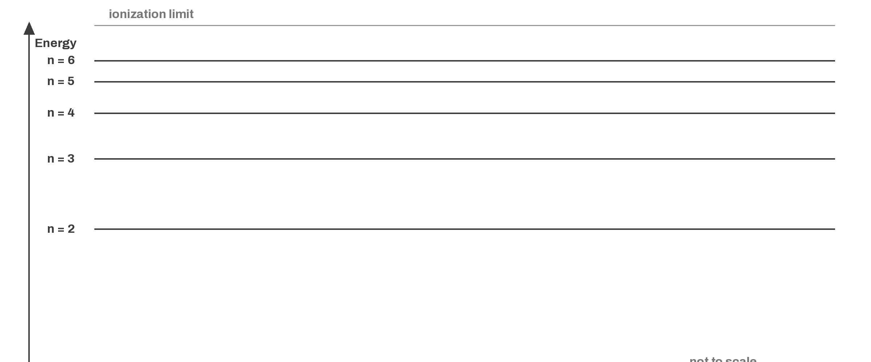
2 Fill in the wavelength and color of each line.

DROP | WAVELENGTH (nm) | COLOR
n = 3 → 2
n = 4 → 2
n = 5 → 2
n = 6 → 2
3 Rank the four drops from least energy to most energy.

4 Use the ladder to explain why the 6 → 2 photon has the most energy and the shortest wavelength of the four.

PART B · IN OR OUT

ELECTRON MOVES | ABSORBS OR EMITS | PHOTON IN OR OUT
n = 1 → 3
n = 4 → 2
n = 2 → 6
n = 5 → 1
6 Which drop gives off more energy, 3 → 1 or 3 → 2? Use the size of the gap in your answer.

PART C · THREE KINDS OF SPECTRA

WHAT YOU SEE | KIND OF SPECTRUM
Every color, with no gaps
Bright colored lines on a dark background
Dark lines across a full rainbow

PART D · FLAME TESTS

FLAME COLOR | ION IT POINTS TO
Yellow
Lilac
Blue-green
9 Li⁺ and Sr²⁺ both give a red flame. Why is a flame color only a clue, not proof of which ion is there?

